

Information Booklet

2018-2019



Revised August 2018
By Mary Ford



Office Information ………………………………….……………….……. 3

Contact Information…………………..…..……………………………….. 4

Useful Phone Numbers…………………………………………………….. 5-6

FIS Learning Assistance…………………………………………………….. 7

Dates and Deadlines to Remember………...………………...…………........ 8-9

Drop/Add Changes and Withdrawals……………………………………… 10

FIS Midterm Grade Reporting and Alert Policy……………………………… 11-12

End-of-Semester Academic Review………………………………………….. 12

Summer Courses ……………………………………………………………... 12

FIS Renewal Grant and FIS Summer Grant………………………………….. 13

FIS Advising and Registration Process ………………………………………. 13

Academic Regulations……………………………………………….................. 13-16

GPA Calculator……………………………………………………………….. 15

Webmail/WebAdvisor/WebCampus …………………………………………. 17-19

STAFF

Prof. Mary Ford, Director of FIS (mford@fdu.edu)
Prof. Gary Meyer, Mathematics Learning Specialist (g_meyer@fdu.edu)
Prof. Cory Johnston, Writing and Learning Strategies Specialist (coryj@fdu.edu)
Ms. Mercedes Allaman, Graduate Assistant

OFFICE LOCATION

Mansion, Third Floor, Room 37

MAILBOX

All staff mailboxes are located in the Literature, Language, Writing, & Philosophy Department

TELEPHONE (973-443-8715)

FAX (973-443-8713)

WEB SITE: www.fdu.edu/fis



Our primary communication with you throughout this year will be via your FDU email account and telephone. It is crucial that you provide FIS with your contact information, especially telephone number(s) where you can be reached (cell phone numbers preferred). If we do not have valid contact information, you will miss out on essential information regarding your classes, registration, meetings, workshops, and so on. If this information changes for any reason during the year, it is your responsibility to provide FIS with updated information.

You can link your FDU email account to any other account of your choosing by following the instructions listed at this link:

http://webdocs.fdu.edu/accounts/rules.html

Academic Support Center: Mr. Darshan Shah, Director (x8538)
Location: Monninger Center

For: Tutoring Services, Computer Lab

Bookstore: (x8656)
Location: Student Center
For: Textbook Purchases, FDU Clothing and Merchandise, Computer Products, Gifts

Career Development: Ms. Donna Jackson-Robertson, University Director (x8945)
Mr. Ryan Stalgaitis, Campus Director (x8945)
Location: Student Center
For: College Work-Study Jobs, Career Assessment, Internships, Resume Writing

Computing Services: (x8822 or email fdutac@fdu.edu)
Location: Dreyfuss Building, Second Floor
For: Password Problems, Log-In Problems, Account Creation

Counseling Services: (x8504)
Location: Cottage, near Danforth Road Gate
For: Personal Counseling, Workshops

Dean of Students: (x8935)
Location: Student Center
For: Verification of Extended Absences, Leave of Absence/Withdrawals from the University, Student Code of Conduct and Discipline/Judicial Affairs

Disability Support Services: Mr. Darshan Shah, Director (x8079)
Location: Monninger Center
For: Disability Accommodations

Enrollment Services (Registration & Records): (x8600)
Location: Mansion, Lower Level
For: Processing Course Add/Drop/Withdrawals, Tuition and Fees, Term Bill and Payment, Transcript Requests, Grade Reports, Enrollment Verifications

Financial Aid Office: (x8700)
Location: Mansion Courtyard
For: Scholarships, Grants, Loans, College Work-Study

Public Safety: Mr. Joseph Vitiello, Director (x8888)
Location: The Barn
For: Emergency Situations/ID Cards, Parking

Library: (x8515)
Location: Adjacent to Mansion lawn
For: Research, Study Space, Use of Databases and Research-Related Skills

Residence Life: (x8586)
Location: Student Center
For: Room Assignments and Changes, Social Programming

Campus Life: (x8570)
Location: Student Center
For: Orientation, Clubs and Organizations, Greek Life, Campus Activities, Intramurals, Special Events, Student Leadership Opportunities

Wellness Center: Health Services: (x8535)
Location: Cottage, near Danforth Gate
For: Illness, Health Education Programs, Men’s/Women’s Health Services, Physical Exams, Nutritional Information, STD Treatment and Info

FIS Learning Assistance

Students in the FIS program have the opportunity to meet one-on-one with the Learning
Specialists to devise individual plans tailored to their learning needs.

Some of the areas in which the Learning Specialists provide one-on-one assistance include:
• Time management
• Reading strategies
• Note-taking techniques
• Study skills and test-taking strategies
• Writing assistance
• Mathematics assistance
• Research skills

Students can schedule one session or multiple sessions with the Learning Specialists. Students who
wish to schedule an appointment should contact Prof. Ford at 973-443-8715. She will assess
students’ needs and determine the appropriate level of assistance.

DATES AND DEADLINES TO REMEMBER
ACADEMIC CALENDAR 2018-2019

Fall 2018

Classes Begin, 8:00 a.m. (Monday)
August 27

Labor Day Holiday (Monday)
September 3

Last Day for New Registrations and Final Drop/Add Changes (Monday)
September 10

Midterm Progress Reporting Opens (Monday)
October 1

Fall Recess (Monday/Tuesday)
October 15-16

Midterm Progress Reporting Closes (Tuesday)
October 23

Last Day for Student Withdrawal from Classes (Friday)
November 2

Priority Registration for Spring Semester 2019
November 5-20

Thanksgiving Recess, Begins 11 p.m. (Tuesday)
November 20
Classes Resume, 8:00 a.m. (Monday)
November 26

Last Day of Fall Classes (Monday)
December 10
Reading/Snow Makeup Days (Tuesday and Wednesday)
December 11-12

Final Examinations (Thursday-Wednesday)
December 13-19
Grades due no later than 5:00 p.m. on the 3rd day after exam is administered.

Fall Semester Ends, 11:00 p.m. (Wednesday)
December 19
Spring 2019

Classes Begin, 8:00 a.m. (Tuesday)
January 22

Last Day for New Registrations and Final Drop/Add Changes (Monday)
February 4

Midterm Progress Reporting Opens (Monday)
February 25

Spring Recess
March 11-16
Online Registration for Summer 2019 Sessions Opens (Friday)
March 15
Classes Resume, 8:00 a.m. (Monday)
March 18

Midterm Progress Reporting Closes (Saturday)
March 23

Last Day for Student Withdrawal from Classes (Friday)
April 5

Priority Registration for Fall Semester 2019
April 8-19

Last Day of Spring Classes (Monday)
May 6
Reading/Snow Makeup Days (Tuesday/Wednesday)
May 7-8
Final Examinations (Thursday-Wednesday)
May 9-15
Grades due no later than 5:00 p.m. on the 3rd day after exam is administered.
Spring Semester Ends, 11:00 p.m. (Wednesday) May 15

University Commencement TBD

Summer Session I 2019
Classes Begin, 8:00 a.m. (Monday)
May 20
Memorial Day Holiday (Monday) May 27
Memorial Day Holiday Makeup Day (Friday)
May 31
Classes End, (Saturday) June 29
Drop/Add Changes and Withdrawals

Drop/Add Changes

At the beginning of each semester, course changes are allowed during the Drop/Add period (approximately two weeks) with the approval of the FIS Director. If you are considering a change in your schedule during the Drop/Add period, you will need to come to our office immediately to address this possibility.

In Fall 2018, course drops after the Drop/Add period are not permitted for students with 13 or 14 credits since it jeopardizes their status as full-time students.

Students taking 16 credits may drop a course with the permission of the FIS Director. If these students have a GPA below 2.0 at midterm, they could be dropped from one of their non-FIS courses by the Director of FIS.

FIS students will not be permitted to seek a drop or withdrawal from their FIS-supported courses. In the fall semester, these courses consist of English, math, and a behavioral or social science course—General Psychology, Geography and World Issues, or American Government and Politics. In the spring semester, FIS courses consist of English, math, and a third course to be determined by the Director of FIS. This third course can be identified on students’ schedules by its 50-minute supplemental FIS hour. Students must complete all of these courses successfully in order to demonstrate satisfactory academic progress in the program and at the university.

Withdrawals

If you are having difficulty in a course, it is always best to come to the FIS office and seek assistance before you decide that you wish to withdraw from that course.

In Spring 2019, the Director of FIS will meet with any student requesting a withdrawal from a
non-FIS course. Please note, however, that course withdrawals are considered only under special circumstances and in instances where the drop will not jeopardize a student’s full-time status. In order to make the transition to college, it is important that you begin to manage a heavier course load your second semester, which is why withdrawals are not always the best option. If you are wondering whether you should withdraw from a course, it is best to come to the FIS office and discuss your options with the Director.

Note: You cannot withdraw from a class without approval from the FIS Director.


FIS Midterm Grade Reporting and Academic Alert Policy

Policy Summary

All FIS students may become involved in campus activities and athletics. However, they are subject to a performance review at midterm each semester, at which point their eligibility for continued participation is determined. Students failing to achieve a satisfactory FIS grade point average at that time will become ineligible for further participation in cocurricular activities.

FIS Midterm Grade Reporting (Fall and Spring Semesters)

Between the third and fourth weeks in October of the fall semester (TBA in the spring semester), all faculty report a midterm grade for each student, as well as the number of absences accumulated by the student. The average of all of your reported grades will determine whether you are making satisfactory progress (above a 2.00) or whether you are placed on Academic Alert. In addition, your grade point average specifically in your FIS-supported classes will be reviewed to determine whether you are making satisfactory academic progress. For students taking only two FIS classes in a semester, the program director may select a third course for midterm grade reporting.

Midterm grades will be posted on WebAdvisor, but you will also receive a printed report.

Note: Although developmental courses (ENGW 0198 and MATH 0298) do NOT factor into the University Cumulative Grade Point Ratio at the end of the semester, grades received in these courses DO count toward the FIS grade point average and midterm grade point average.

Consequences of FIS Academic Alert

Students placed on FIS Academic Alert at the time of review will cease participation in all
cocurricular and extracurricular activities for the remainder of the semester. This means that the student activities listed below are suspended in the fall from November 1st until the end of the semester and in the spring from April 1st through the end of finals week.

The areas affected by probation include the following:

- Athletics
- Leadership positions in all student organizations (includes all fraternities and sororities)

In addition, these students may be required to meet with a member of the FIS staff in order to develop an academic plan for success. Any additional requirements will be noted on a letter that accompanies the midterm grade report.

Following the fall semester, if the student’s GPA falls below 2.00, participation in cocurricular activities will continue to be suspended for the spring until midterm grade reporting occurs in March. At that point, the student’s record will be re-evaluated for eligibility.

While FIS probation does not appear on your academic transcript, it must be taken seriously, as it is a part of the program requirements to which you have agreed.

Fraternity and Sorority Pledging
Students who wish to pledge a fraternity or sorority at the beginning of the spring semester will have their eligibility determined by the Office of Student Life. The university has a credit requirement as well as a GPA requirement for pledging.

End-of-Semester Academic Review

In addition to FIS review for program-specific requirements, a formal end-of-semester Academic Review is performed by the faculty of Becton College following the fall and spring semesters. This Academic Review process pertains to ALL students enrolled in Becton College, not just FIS, and includes grades earned in ALL courses. Any student with a grade point average below 2.0 will receive a formal letter (sent by certified mail to the student’s home address) from the Associate Dean of Becton College, inclusive of any restrictions imposed for the following semester. Accompanying this letter will be a letter from the Director of FIS, which will include any additional program restrictions or requirements. Only notations of Becton College probation will appear on the transcript.

Summer Courses
Some students may choose to take summer session classes at FDU to improve their grade point averages and to continue making academic progress. We strongly encourage students to take courses in Summer Session I in order to acquire more credits and to fulfill more of their general education requirements. In the spring semester, FIS will recommend appropriate courses for students to take in the summer.
Students may wish to seek classes at a college close to home, and they are eligible to do so if they meet specific criteria. The criteria will be discussed during an advising workshop in the spring semester.
Further information regarding the off-campus course authorization policy can be found online at: http://view.fdu.edu/default.aspx?id=2314

FIS Renewal Grant and FIS Summer Grant

By successfully completing their FIS program year, students will qualify to receive an annually
renewable FIS grant during each of their three remaining years at FDU (based on maintaining continued satisfactory academic progress). Students should contact the Financial Aid office for further information regarding the GPA requirement and year-end credit requirement for eligibility of this grant.

Please note that the FIS summer grant will only be offered for Summer 2019 and it can only be used towards summer enrollment at FDU on the Florham campus or the Teaneck campus. Additional information regarding summer courses at FDU will be provided during a spring FIS workshop.

The FIS Advising & Registration Process
All advising and registration concerns should be directed to the FIS office, not to any of the other advising centers on campus. You will not use those advising systems until you are ready to register for sophomore-year classes.
During either the first or second week of November, you will receive an advising packet in your Transitioning to University Life class that will include important information about spring course scheduling and how to access your checksheet online for your intended major.
In the following week, you will attend a one-hour advising session to be held in the Academic Support Center computer room. This is a mandatory meeting—failure to attend will result in your inability to register for spring classes.
Academic Regulations

ATTENDANCE
Students are required to attend class, arrive on time, and participate in all courses for which they are enrolled. Class attendance and participation are essential to academic progress. At the beginning of each semester, instructors will express the specific attendance requirements for each course according to the policies of their academic departments and colleges. The policy will clearly delineate the number of permissible absences and the sanctions to be applied for excessive absences or tardiness. Each instructor will include the attendance policy on each syllabus to prevent any misunderstanding of the requirements for the course.
What should students do in cases of extended absence from class?
If you are going to be absent from class for an extended period of time (a week or more) due to illness or emergency, you MUST contact the Dean of Students Office in order to document that absence. If verified and accepted, the Dean of Students will send a letter to your instructors, informing them of the absences. You should, of course, contact your professors anyway. In all cases, the onus is on you to accept responsibility for missed class time.

STUDENT STATUS
Student status shall be determined by the number of credits per fall or spring semester. A full-time student is one who registers for 12 or more credits, and a part-time student is one who registers for less than 12 credits. Students in the FIS program must be full-time students.

ACADEMIC STANDARDS
The University expects its students to make normal progress toward a degree. This means the attainment of at least a 2.00 grade point ratio for each semester. Students whose grade point ratio falls below 2.00 will receive notification in writing at the end of the semester.

In addition, financial aid recipients should note that failure to maintain academic progress (minimum grade point average AND a minimum number of credits earned) could result in a loss of financial aid. You should refer to your financial aid package for details on satisfactory academic progress to receive financial aid.

COLLEGE PROBATION POLICY
A student will be placed on probation if the semester or cumulative grade point ratio (CGPR) falls below 2.00. A student will be on continued probation for one semester if the semester grade point ratio is 2.00 or higher, but the CGPR is below 2.00. Thereafter, the student must maintain a semester grade point ratio of at least 2.20 until the CGPR reaches 2.00 to continue with a full academic load. A CGPR of at least 2.00 is required for graduation (2.33 required in the major for students in Becton College).

REPEATED COURSES
If a student repeats a course, both the first and second (third, etc.) grades will remain on the transcript, but only the last earned grade will be computed in the cumulative grade point ratio (CGPR). (Note: weighted NC, W, I and AU are not considered earned grades.) Both courses must be taken at Fairleigh Dickinson University.

If a student has been found guilty of academic dishonesty, the F grade for this course is not removed from the student’s transcript or from the cumulative grade point ratio calculation when the course is repeated.

Students failing courses in the fall semester will retake those classes in the spring in order to maximize their chances of bringing up their overall GPAs.

GRADES AND GRADE POINTS
A system of grade points is used to determine a student's general average. Letter grades are used to evaluate performance, and each credit hour is assigned grade points. Assigned letter grades and grade points are as follows:
A = 4.00 C+ = 2.33
A- = 3.67 C = 2.00
B+ = 3.33 C- = 1.67
B = 3.00 D = 1.00
B- = 2.67 F = 0.00
The grade point ratio of a student is equal to the total number of grade points divided by the total number of credits attempted.

GPA CALCULATOR
In order to calculate your grades, you may find the following online GPA calculator useful:

http://www.fdu.edu/studentsvcs/gpacalc2.html

The value of other letter grades is as follows:
P = Pass
NC = No Credit
W = Withdrawal
I = Incomplete
AU = Audit

Regulations governing letter grades:
P=Pass
to be counted toward baccalaureate requirements but not averaged into students' cumulative grade point ratios (CGPR).

NC=No credit
not to be credited toward the baccalaureate requirements nor averaged into the CGPR.

W=Withdrawal
not to be credited toward the baccalaureate requirements nor averaged into the CGPR. A student may withdraw from a course through the ninth week of a semester (through the fourth
week of a six-week summer session) with the permission of his/her advisor ONLY. After
the ninth week (fourth week in a six-week summer session), withdrawal may be permitted
for serious, documented, medical reasons or other unusual extenuating circumstances.
Students requesting late withdrawals should present evidence of unusual circumstances and/or medical documentation to the dean of the College.

I=Incomplete
This designation is not a substitute for a letter grade. It merely describes a student's temporary status in a course. It is to be given only in exceptional or emergency circumstances at the discretion of, and after consultation with, the instructor. Students have a responsibility for completing all work in a course on time. They have the added responsibility of notifying the instructor of circumstances preventing them from completing the requirements on time. Students will have up to the third week of the next full semester (excluding summer sessions) to complete the requirements. If the requirements have not been met within the prescribed period, the “I” automatically will become an F. The F is a letter grade and will count in the student's CGPR.

LEAVE OF ABSENCE
A leave of absence that permits a student to return without academic penalty may be granted only to a matriculated student with a cumulative grade point ratio of 2.00 or higher. A leave may cover only one semester with the privilege of renewal for one more consecutive regular semester.

A leave of absence may be granted for:
(1) medical (2) financial (3) employment or (4) military reasons

Verification in writing must be furnished where applicable by the physician, employer, or other authority.

Authority to grant a leave of absence resides with the Dean of Students. However, the FIS program requires that students seeking a leave of absence obtain a signature from the FIS Program Director.

STATEMENT OF WITHDRAWAL FROM COURSE(S) (ADD/DROP)
Once students have been registered for courses (processed in the Office of Enrollment Services), they have signed a commitment with the University. Students will be billed for those courses and will be held responsible for the payment of the tuition and all fees for the semester.

Nonpayment of tuition and/or nonattendance (never attending a class) by the student will not constitute an official withdrawal. You must complete official paperwork to withdraw from a course. It is best to see your advisor if you are considering withdrawing from a course or from the university.

For further details, please refer to the current Undergraduate Studies Bulletin.

HONORS AND DEAN'S LISTS
The Honors List and Dean's List are issued each semester and contain the names of students who have achieved a grade point ratio of at least 3.50 and 3.20 respectively. To be eligible, full-time students must complete a minimum of 12 credits during a semester. Weighted letter grades must be earned for all courses except for one that may be taken on a P/NC basis and may be included provided that a P grade is earned.

ACADEMIC INTEGRITY POLICY
Students enrolled at Fairleigh Dickinson University are expected to maintain the highest standards of academic honesty. Students have the responsibility to each other to make known the existence of academic dishonesty to their course instructor and then, if necessary, the department chair or the academic dean of their College. Please see the Undergraduate Studies Bulletin for specific examples of academic dishonesty (cheating, plagiarism, falsification, multiple submission, complicity, and interference).
A detailed description of the academic integrity policy is located in the 2018-2019 Student Handbook. You are responsible for this information!

the Important 3W’s--Webmail, WebAdvisor, WebCampus
- Webmail is your FREE FDU email account. You MUST create an account before the first day of classes; a Webmail account will enable you to access WebCampus.

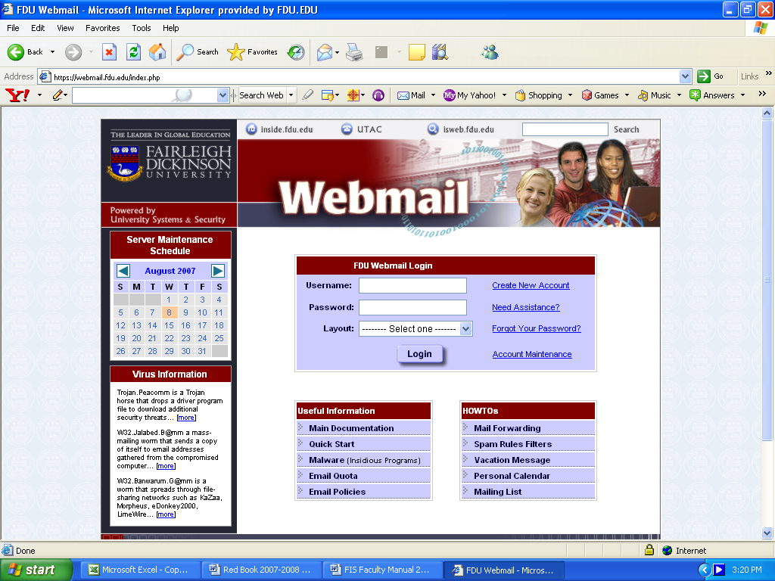

- WebAdvisor is the University’s online system that connects you to the following:

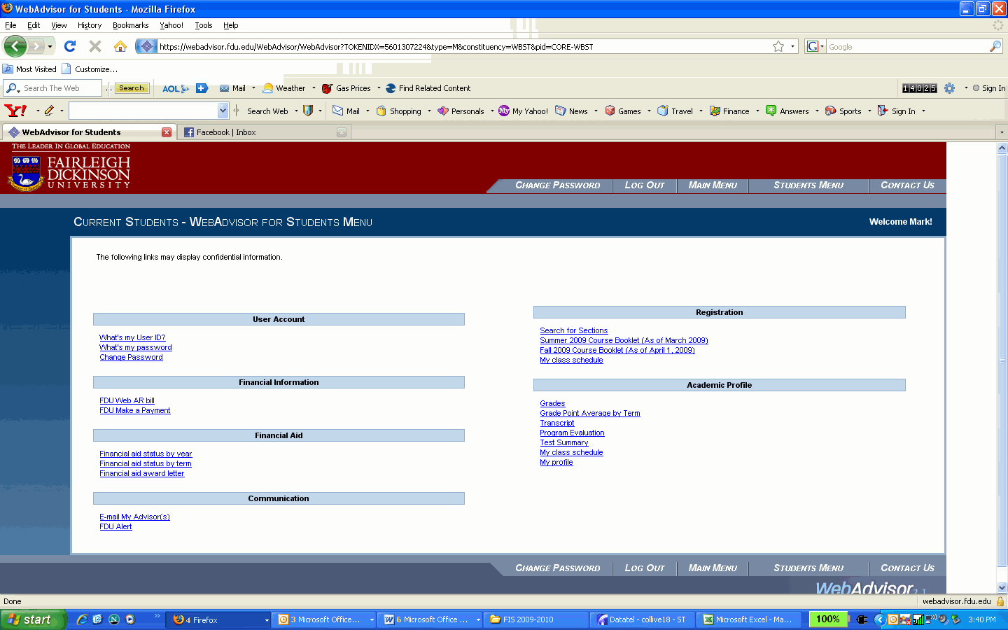

- WebCampus
WebCampus is the online system you will use when you take any distance-learning course. The software running on the WebCampus server is called Blackboard. You will become very familiar with these terms during your FDU career. All courses for which you are registered have a Blackboard shell—your professors may post the course syllabi and other course materials there.
FIS has developed a special Blackboard community just for you under “My Organizations.”
In order to access WebCampus, you will first need to have an active Webmail Account and be actively registered for classes.
