Creating a Case in Retention Alert

Step 1: Go to Webadvisor

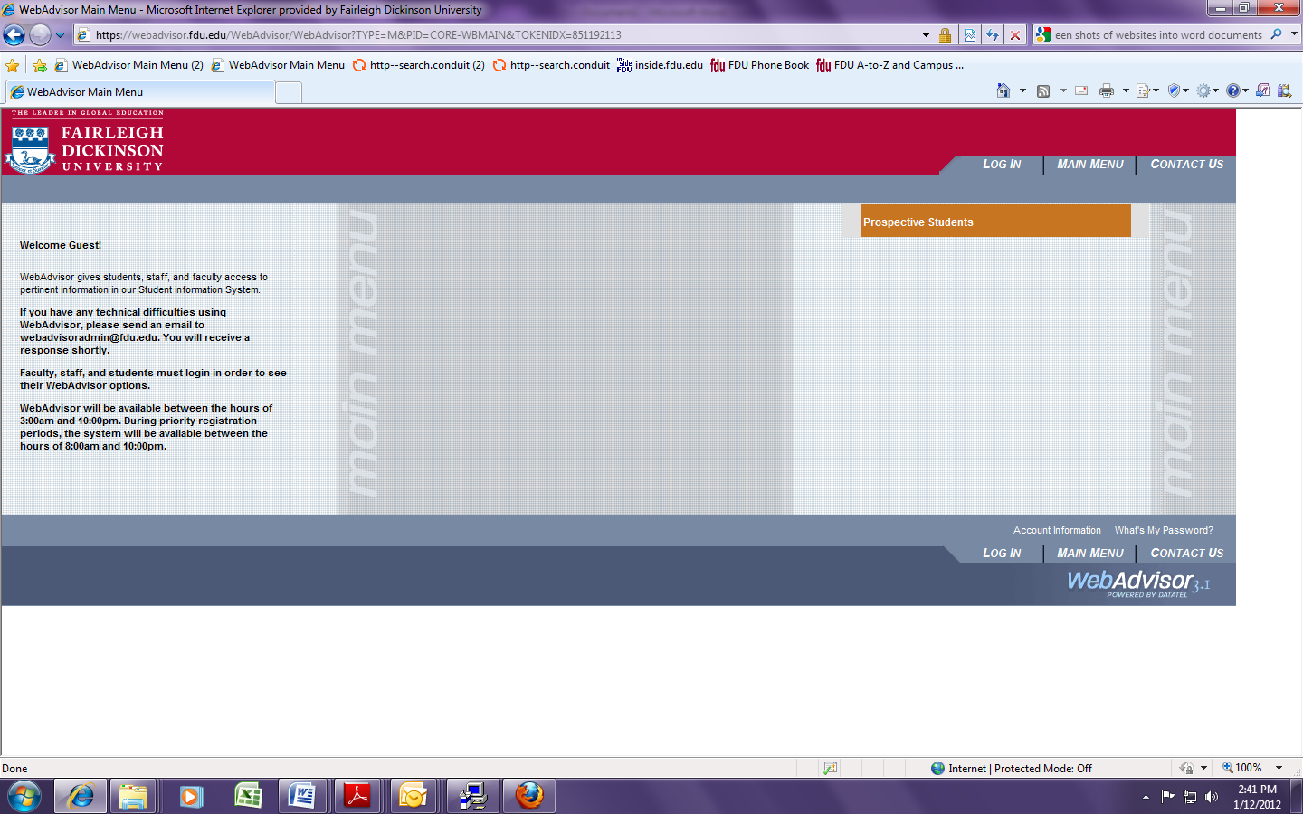

Step 2: Click on the Log-In Tab

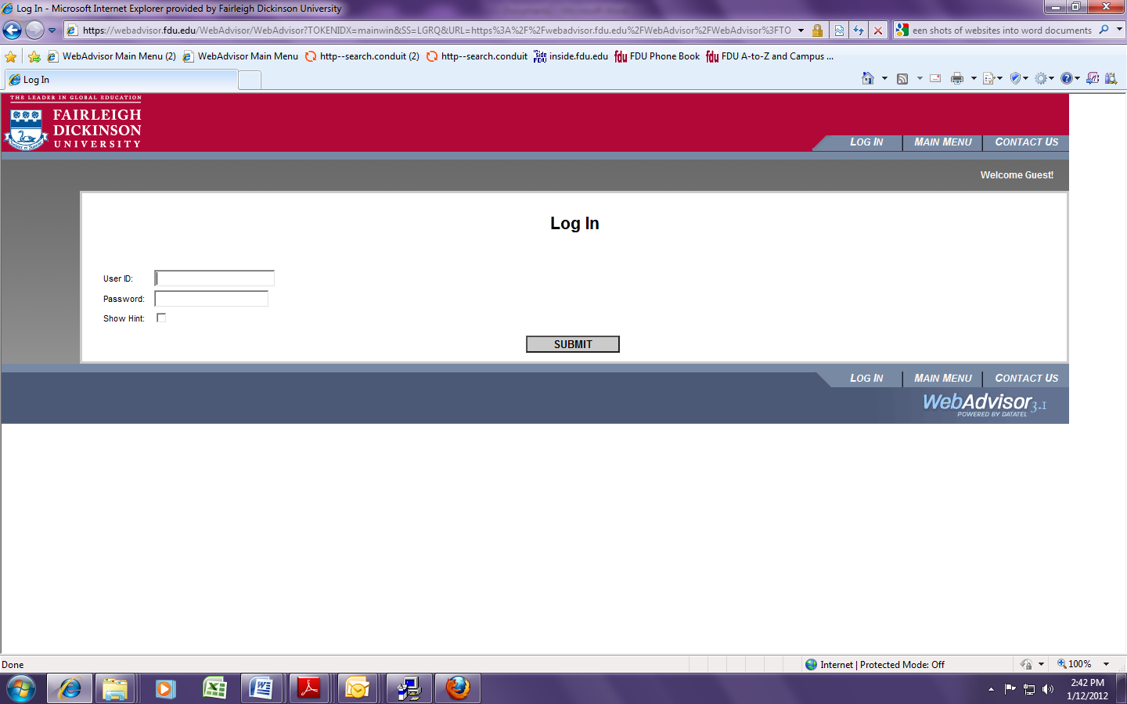

Step 3: Enter User ID and Password (if you do not have a WebAdvisor account, contact webadvisoradmin@fdu.edu)

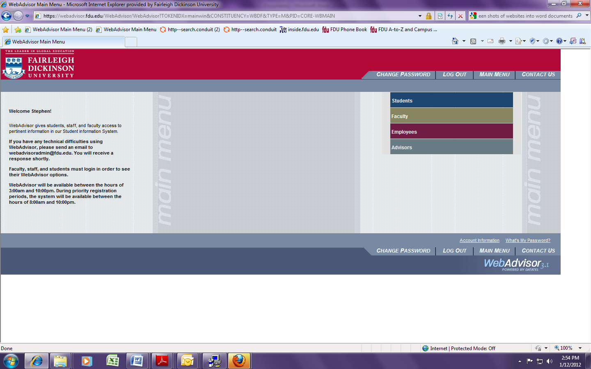

Step 4: Click on Faculty

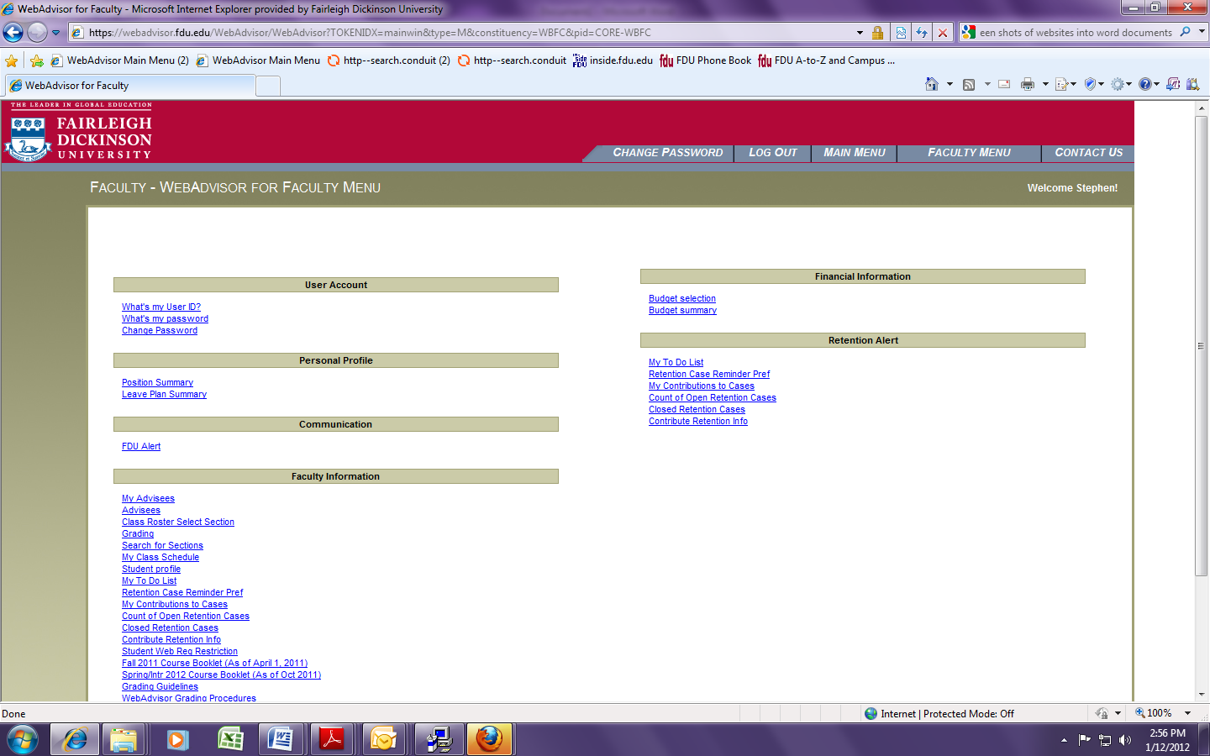
Step 5: Under Retention Alert, click Contribute Retention Info (your faculty menu may not include all the links that the screen shot above contains, but all faculty will have the “Contribute Retention Info” link.)

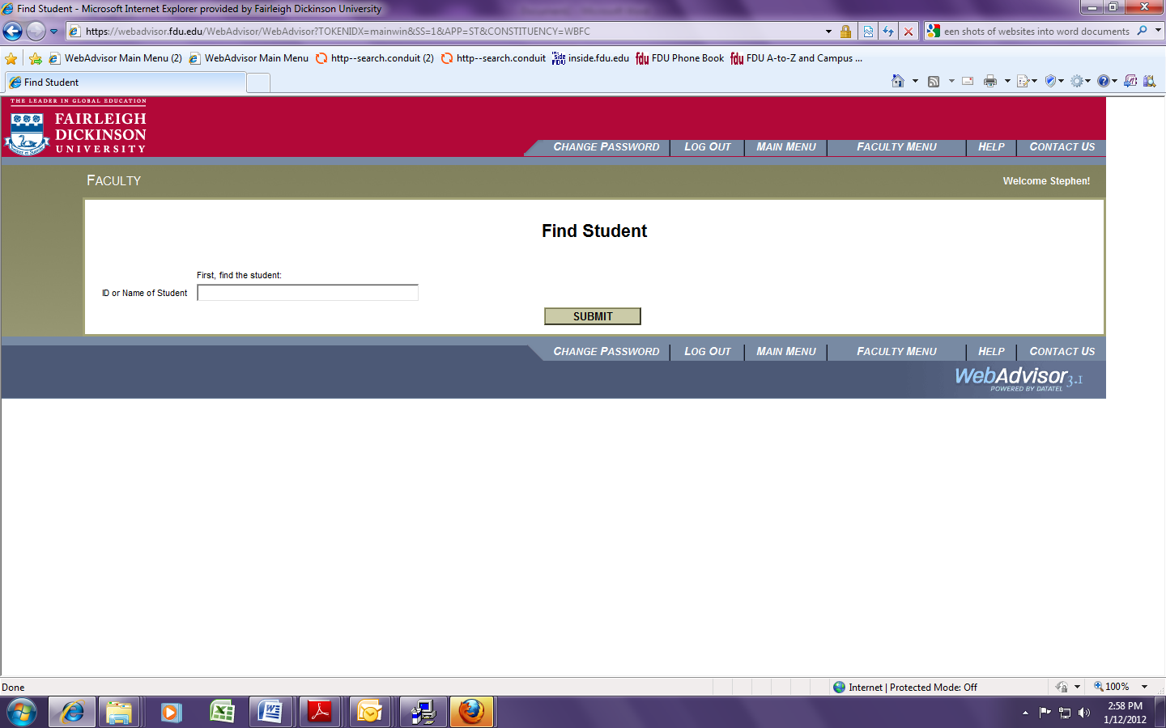

Step 6: Enter student name or ID number (you can also go into your class roster in WebAdvisor and click on a students name to contribute retention info—when you click on the student name, the student profile will open and at the bottom of the screen will be a link to contribute retention info)

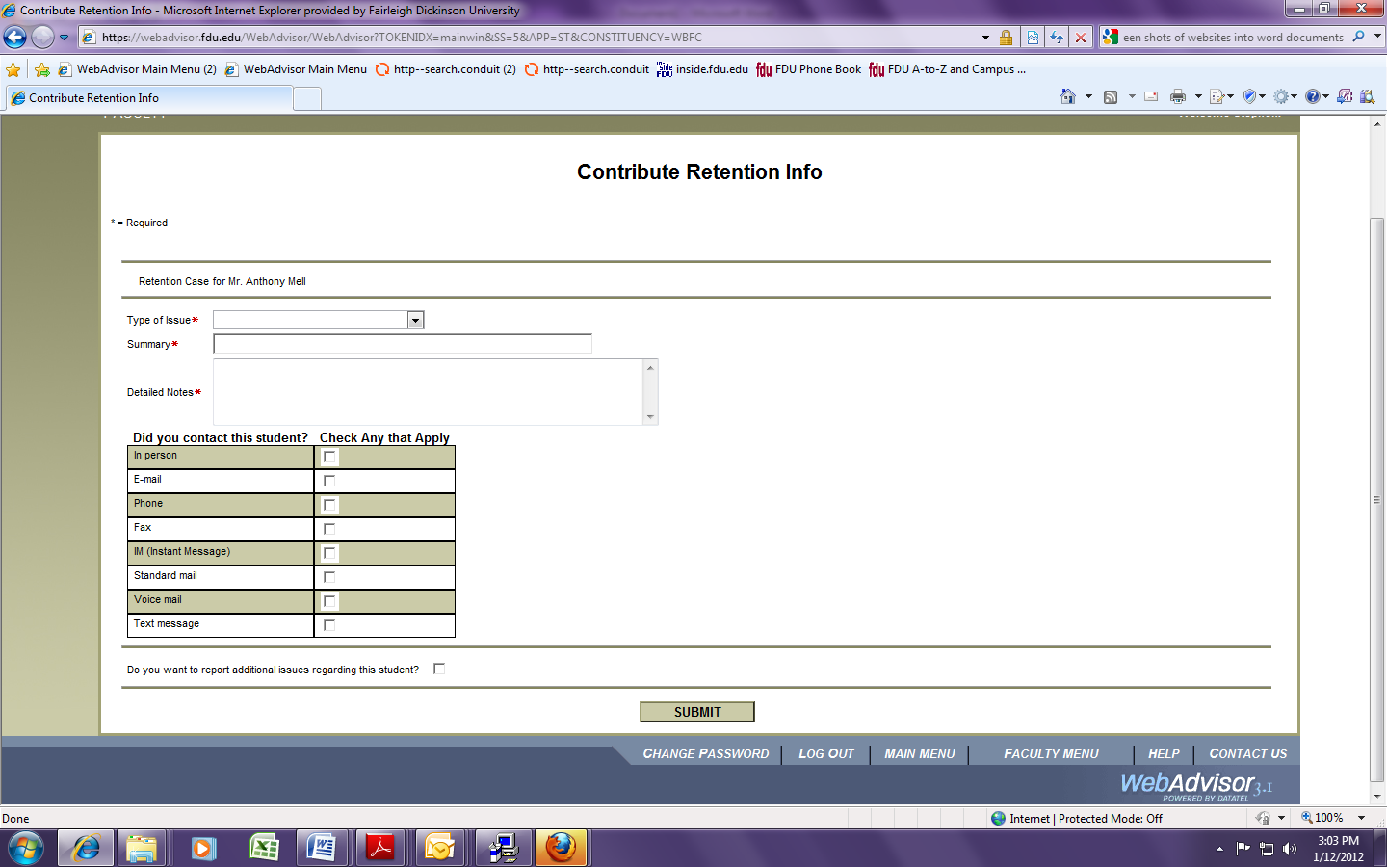

Step 7: Choose Type of Issue

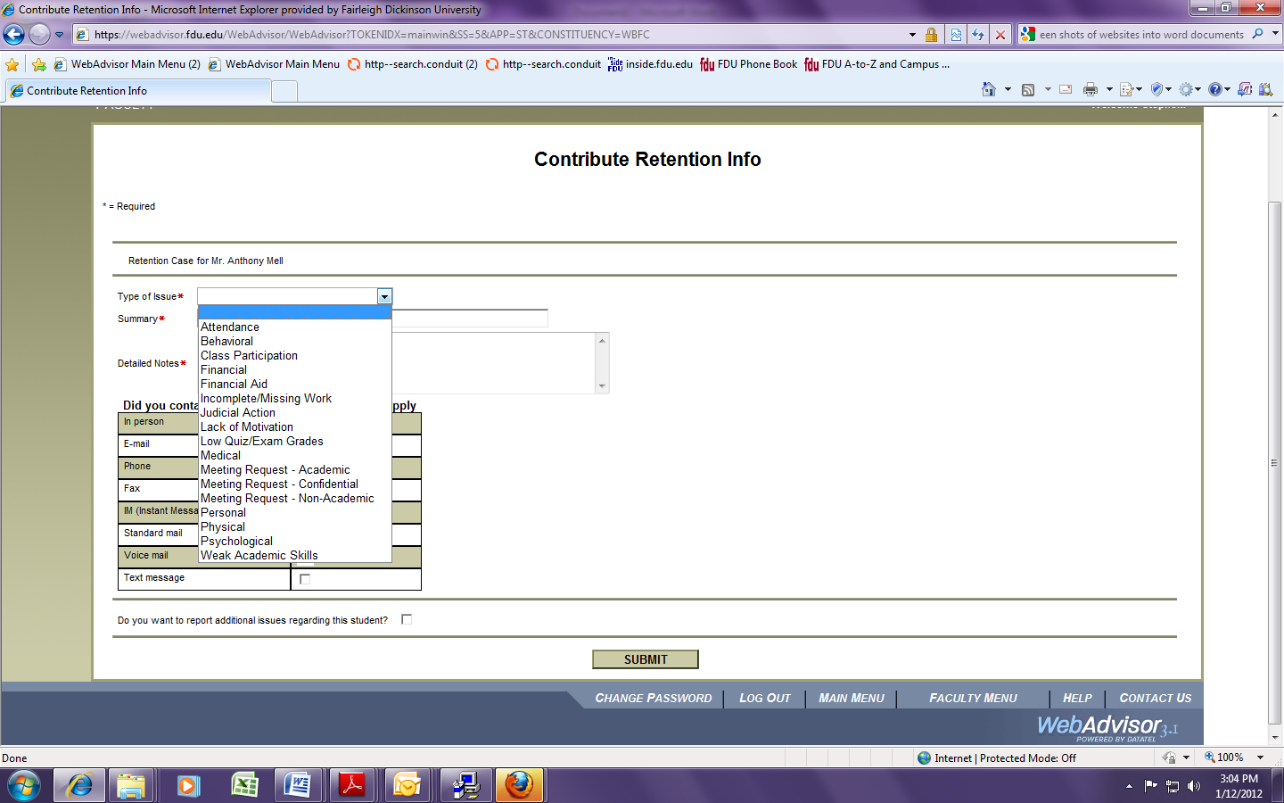
Step 8: Write a summary of the issue

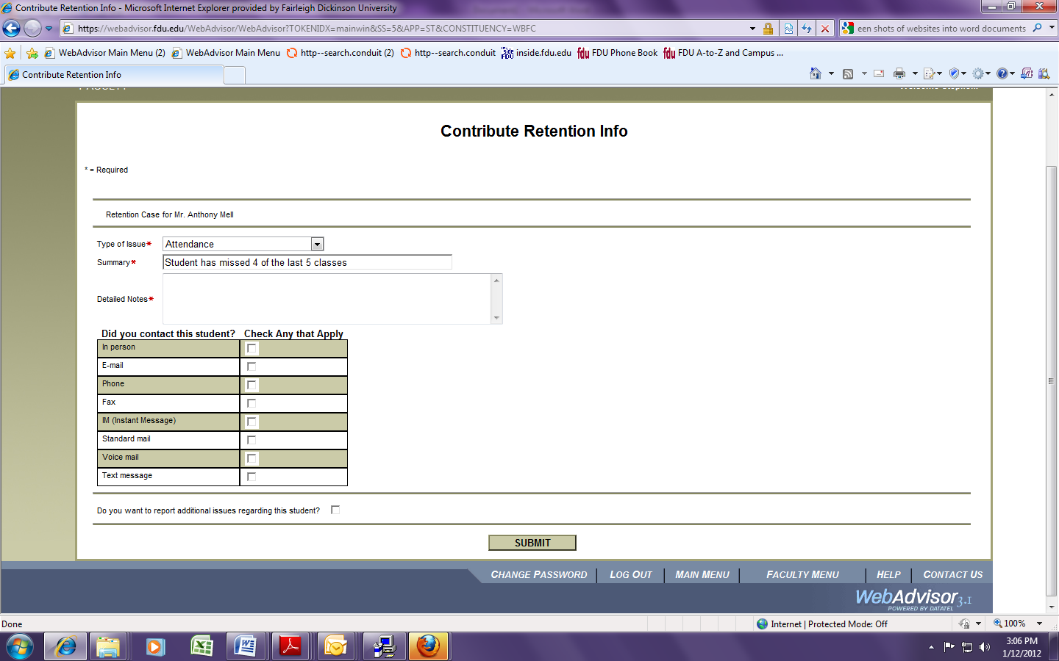

Step 9: Include any additional notes.

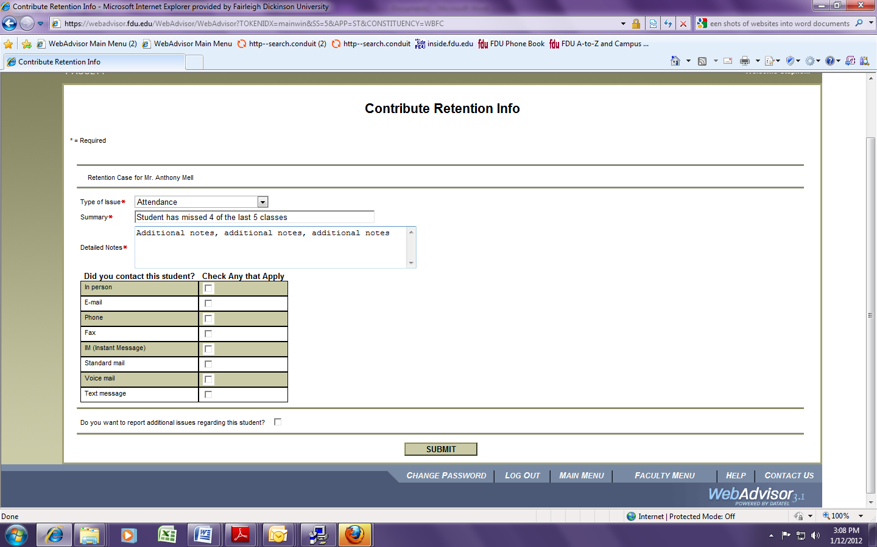

Step 10: Check contact boxes (if any apply)

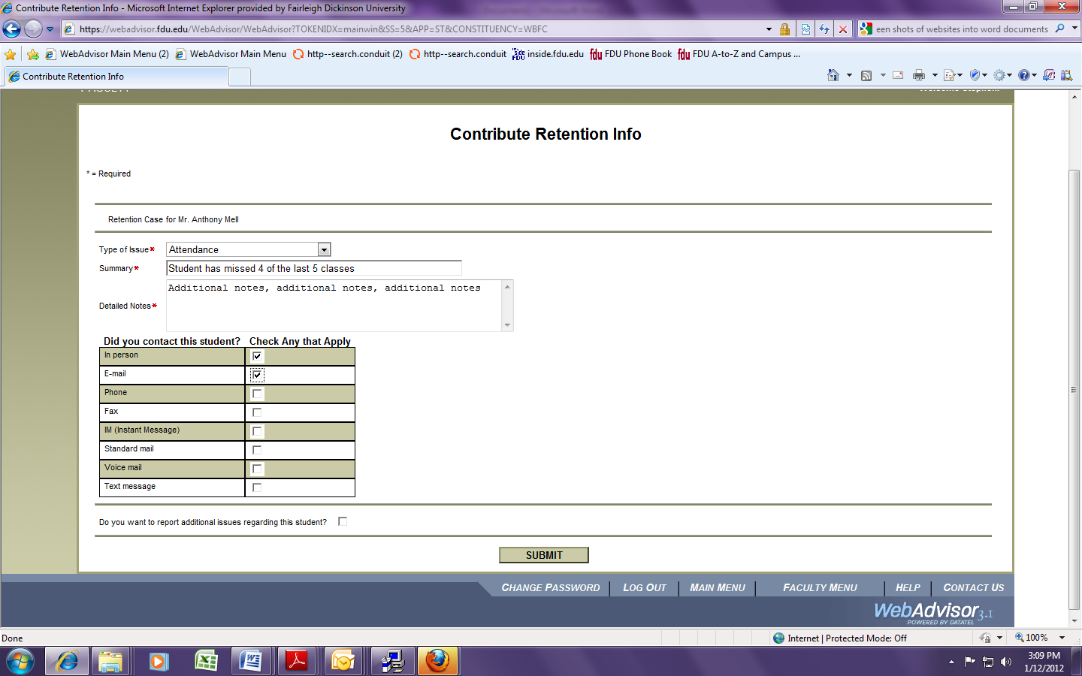
Step 11: If you have any additional issues regarding the same student, check the box next to the question.

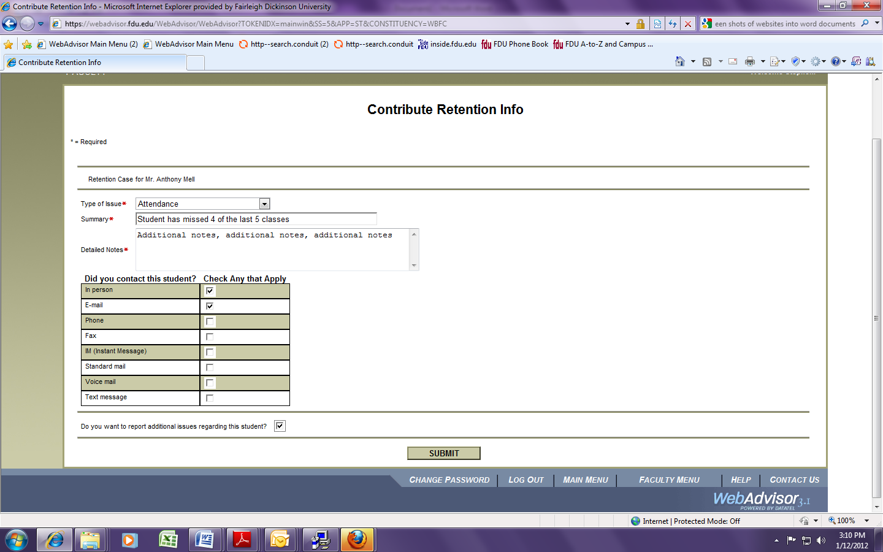

Step 12: Click on Submit. The next screen will tell you who the case was assigned to.
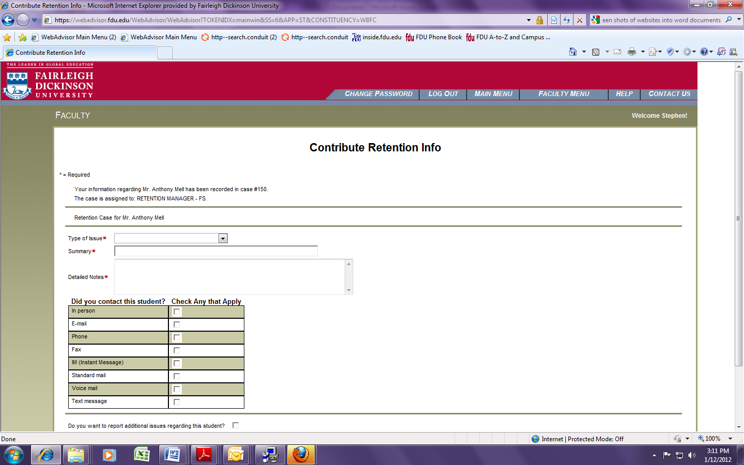

Once the case has been assigned, to protect the student’s confidentiality, you may or may not be notified directly from the case manager about what is being done about the case. You will however, be notified by the system when the case is resolved and closed.

