REGISTRATION FORM
for use by
Online Undergraduate Students

Office of
Online UG
Programs

SEMESTER: SPRING SUMMER I
UNDERGRADUATE (Please indicate) FALL SUMMER II YEAR 20

STUDENT I.D. NUMBER LAST NAME FIRST NAME MI

HOME ADDRESS STREET CITY STATE ZIP
AA BAIS
ACADEMIC PROGRAM E-MAIL ADDRESS HOME PHONE NO. BUSINESS/CELL PHONE NO.

SUBJ & CAT NO | SECT | COURSE TITLE | DAYS & TIME | CR | ALTERNATE SECTION/ COMMENTS
TOTAL CREDITS

Registration contract: I understand that enacting a registration creates a legal contract with the University that results in the holding of all classes. This registration generates an indebtedness to the University that can be reduced or cancelled upon the receipt of a signed statement from the student within the time frame outlined in the cancellation clause (see page 2). Registering for coursework certifies that you are fully aware of and accept the terms of this contract as stated. Payments received after the last day of the term will be assessed a 12% late fee.

ATTENTION: THE STUDENT is ULTIMATELY RESPONSIBLE FOR ENROLLING IN THE APPROPRIATE COURSE AND SECTION. DROPPING BELOW 12 CR (UNDERGRAD) OR 4.5 CR (GRAD) DURING THE REGULAR SEMESTERS WILL JEOPARDIZE FINANCIAL AID AND ATHLETIC ELIGIBILITY.

E.S. USE ONLY
CLERK DATE CR

STUDENT SIGNATURE ADVISOR’S SIGNATURE ADDITIONAL SIGNATURE (if required) DATE

SEE PAGE 2 FOR CANCELLATION / REFUND POLICIES ENROLLMENT SERVICES
______________________________________________________________________________________

Payment Information
Once registration is completed you will receive a confirmation of registration via email. You can view your bill via WebAdvisor.

Please indicate intended method of payment:
Third Party Billing: Fax signed Letter of Credit to Vanessa Eatman at 201-692-2209.
Booz Allen Hamilton Employee: Complete Booz Allen Tuition/Certification Request Form and remit payment to FDU.
Corporate Reimbursement Deferred Payment Plan: Complete form* and remit 4% of the total amount to be deferred.
*if checked, form will be emailed with confirmation of registration.
Active Duty Military (FTA): send completed FTA form to online@fdu.edu or fax to 201-692-7359
Other: _____________
Online Undergraduate Students
SIGN & RETURN COMPLETED REGISTRATION FORM BY:

Fax: 201-692-7359
Email: jteller@fdu.edu or jsteiner@fdu.edu

Tuition Policies

PAYMENT DEADLINE
Please adhere to payment deadlines and policies established by the University for each semester. Failure to comply will result in late charges.

REFUND/ CANCELLATION OF TUITION AND FEES
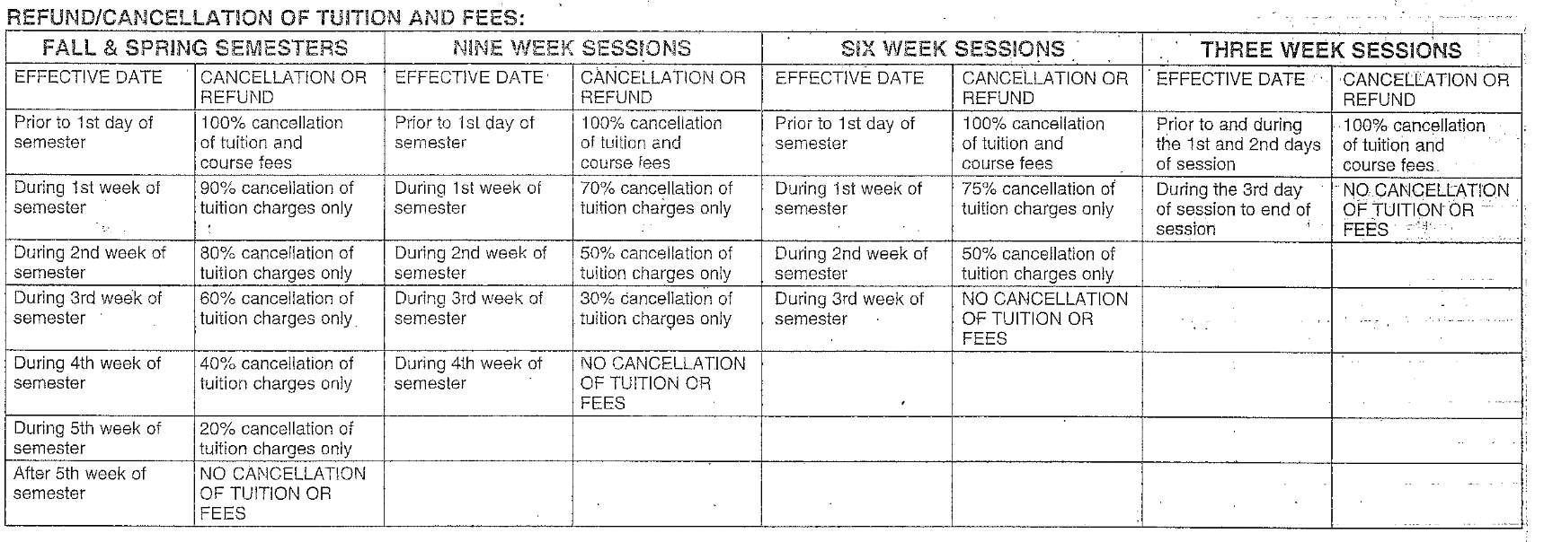

During final two weeks of semester WITHDRAWALS FOR THE TERM ARE NO LONGER ACCEPTED.

CANCELLATION CLAUSE
The Effective Date of any alterations of a student’s schedule will be the official date of receipt. Only those alterations with an Effective Date prior to the first day of classes will be accorded a 100% cancellation of charges.

COLLECTION FEE
By registering for a course or courses, the student has entered into a contractual agreement with Fairleigh Dickinson University and has a financial obligation to pay the expenses incurred. In the event the student fails to honor his/her financial obligation, the student will also be responsible to pay all collection costs associated with the University’s attempt to collect the past due balance; collections costs can include a third party collection fee of 30% of the past due balance. The University reserves the right to report unpaid account information to any credit bureau.

LATE PAYMENT CHARGES
A late payment charge will be collected at the time any payment (full or partial) is applied to an outstanding balance. Late payment charges will begin at the rate of 2%. Payments received after the last day of the term will be assessed a 12% late fee.

CORPORATE VOUCHER
All third party corporate vouchers must be submitted at the time of registration.

