Office of
Online
Programs

SEMESTER: FALL SUMMER I YEAR 20
(Please indicate) SPRING SUMMER II

STUDENT I.D. NUMBER LAST NAME FIRST NAME MI

HOME ADDRESS STREET CITY STATE ZIP
AA BAIS
ACADEMIC PROGRAM E-MAIL ADDRESS HOME PHONE NO. BUSINESS/CELL PHONE NO.

COURSE(S) TO BE DROPPED |  |  |  | COURSE(S) TO BE ADDED
SUBJ & CAT NO | SECT | CR |  | SUBJ & CAT NO | SECT | COURSE TITLE | DAYS & TIME |  | CR
 |  |  |  |  |  |  | Web
TOTAL CREDITS AFTER ADD/DROP

Registration contract: I understand that enacting a registration creates a legal contract with the University that results in the holding of all classes. This registration generates an indebtedness to the University that can be reduced or cancelled upon the receipt of a signed statement from the student within the time frame outlined in the cancellation clause (see Page 2). Registering for coursework certifies that you are fully aware of and accept the terms of this contract as stated. Payments received after the last day of the term will be assessed a 12% late fee.

ATTENTION: THE STUDENT IS ULTIMATELY RESPONSIBLE FOR ENROLLING IN THE APPROPRIATE COURSE AND SECTION. DROPPING BELOW 12 CR (UNDERGRAD) OR 4.5 CR (GRAD) DURING THE REGULAR SEMESTERS WILL JEOPARDIZE FINANCIAL AID AND ATHLETIC ELIGIBILITY.

Registrant’s attestation required for electronic submission. By checking this box, I agree to the terms of this registration contract.
E.S. USE ONLY
CLERK DATE CR

STUDENT SIGNATURE ADVISOR’S SIGNATURE ADDITIONAL SIGNATURE (if required) DATE

SEE PAGE 2 FOR CANCELLATION / REFUND POLICIES ENROLLMENT SERVICES
___________________________________________________________________________________

Students in the Online AA or Online BAIS should return hand-signed form by either method:

Email: blogue@fdu.edu or jsteiner@fdu.edu
Fax: 201-692-7359

Tuition Policies

PAYMENT DEADLINE
Please adhere to payment deadlines and policies established by the University for each semester. Failure to comply will result in late charges.

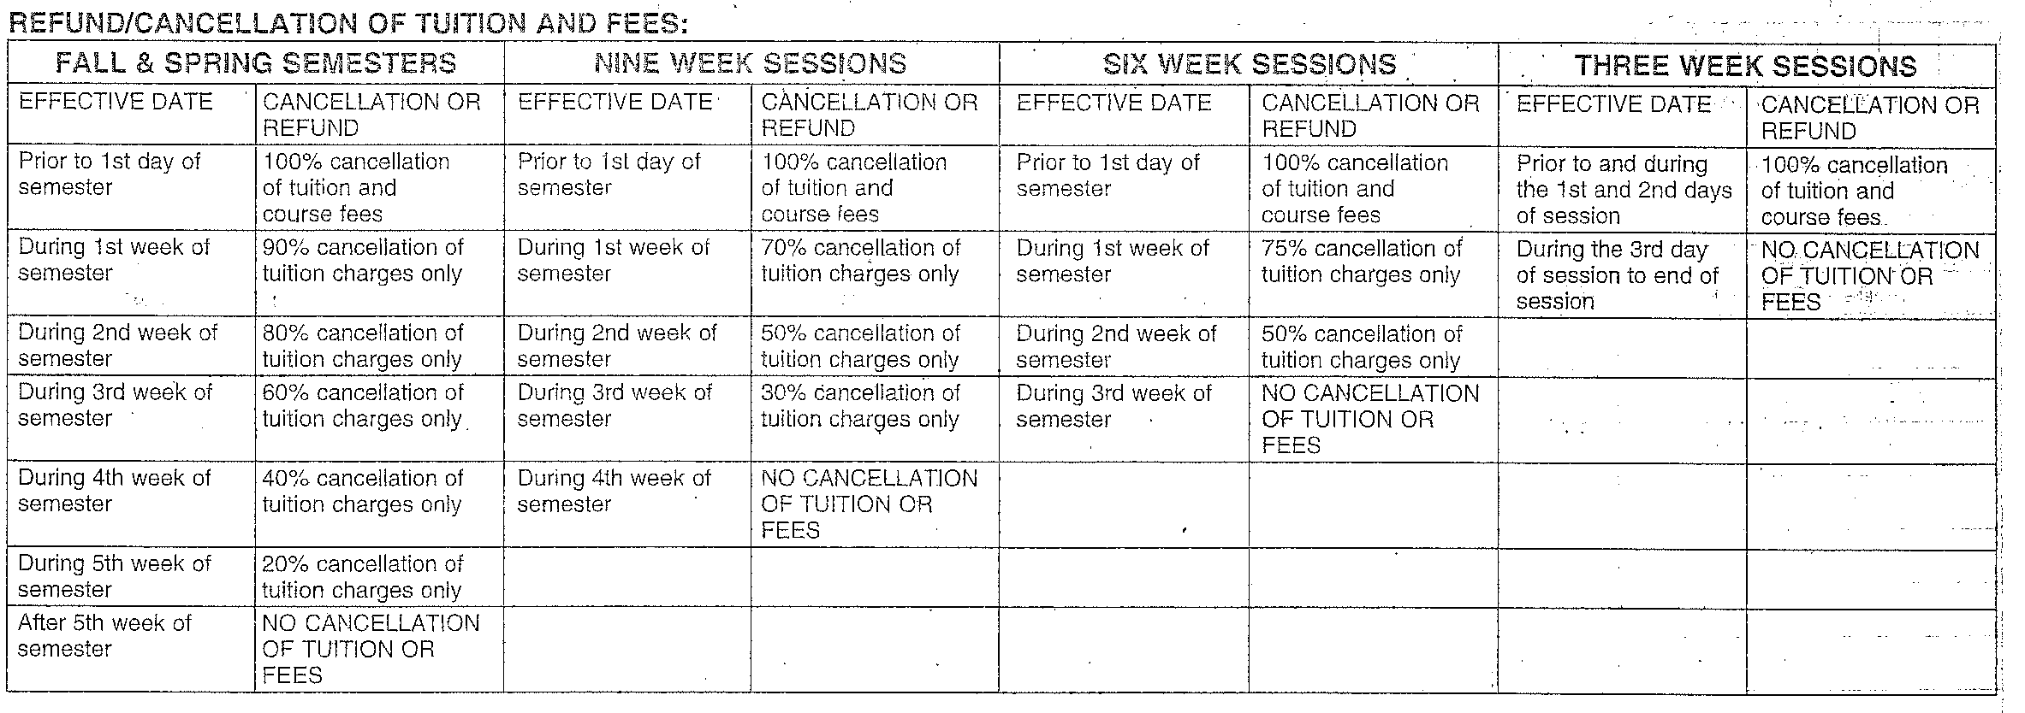
REFUND/ CANCELLATION OF TUITION AND FEES

During final two weeks of semester WITHDRAWALS FOR THE TERM ARE NO LONGER ACCEPTED.

CANCELLATION CLAUSE: The Effective Date of any alterations of a student's schedule will be the official date of receipt. Only those alterations with an Effective Date prior to the first day of classes will be accorded a 100% cancellation of charges.

COLLECTION FEE: By registering for a course or courses, the student has entered into a contractual agreement with Fairleigh Dickinson University and has a financial obligation to pay the expenses incurred. In the event the student fails to honor his/her financial obligation, the student will also be responsible to pay all collection costs associated with the University’s attempt to collect the past due balance; collection costs can include a third party collection fee of 30% of the past due balance. The University reserved the right to report unpaid account information to any credit bureau.

LATE PAYMENT CHARGES: A late payment charge will be collected at the time any payment (full or partial) is applied to an outstanding balance. Late payment charge will begin at a rate of 2%. Payments received after the last day of the term will be assessed a 12% late fee.

CORPORATE VOUCHER: All third party corporate vouchers must be submitted at the time of registration.

